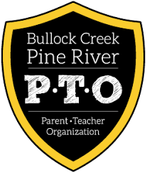

**Reading Rainbow**

Name:________________

Teacher:______________

All entries MUST be turned in by Monday, March 21st.

**March is Reading Month! Celebrate with the**

**Bullock Creek/Pine River PTO by entering our drawing!**

1. Fill out the form on the right side of the page.
2. Read a book (or 5 chapters of a longer chapter book) and color in a piece of the rainbow.
3. When your rainbow is complete, turn it in to your teacher for a chance to win a prize!

